** BLINKIT DATA ANALYSIS**

* The data can be seen by:

**select * from blinkgroc;**

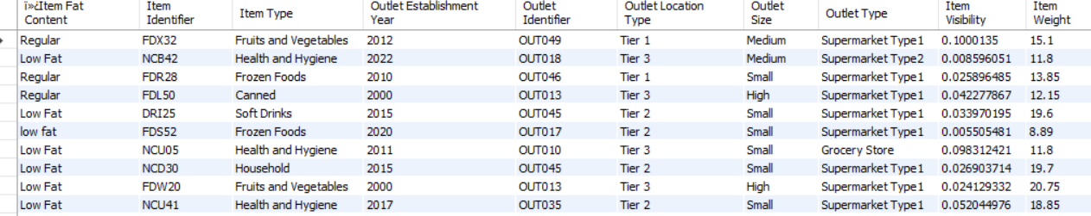

* Now to some data preprocessing:

Cleaning the Item_Fat_Content field ensures data consistency and accuracy in analysis. The presence of multiple variations of the same category (e.g., LF, low fat vs. Low Fat) can cause issues in reporting, aggregations, and filtering. By standardizing these values, we improve data quality, making it easier to generate insights and maintain uniformity in our datasets.

**-- 1. Disable safe update mode(You may get this error )**

**SET SQL_SAFE_UPDATES = 0;**

**-- 2. Perform the update**

**UPDATE blinkgroc**

**SET `Item Fat Content` =**

**CASE**

**WHEN `Item Fat Content` IN ('LF', 'low fat') THEN 'Low Fat'**

**WHEN `Item Fat Content` = 'reg' THEN 'Regular'**

**ELSE `Item Fat Content` END;**

* **SELECT `Item Fat Content`, COUNT(*) AS count**

**FROM blinkgroc**

**GROUP BY `Item Fat Content`;**

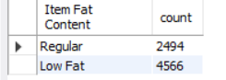

.

**Now analysing Key Performance Indicators:**

1. **Total Sales**:

**SELECT ROUND(SUM(`Total Sales`)/1000000, 8) AS `Total Sales (Millions)`**

**FROM blinkgroc;**

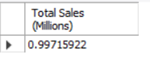

1. **Average Sales:**

**SELECT AVG(`Total Sales`)/1000000 AS `Average Sales (Millions)`**

**FROM blinkgroc;**



1. **No of items:**

**SELECT COUNT(*) AS NUM_OF_ORDERS**

**FROM blinkgroc;**



1. **AVERAGE Rating:**

**SELECT AVG(`Rating`) AS AVERAGE_RATING**

**FROM blinkgroc;**



**Now analysing total sales by Fat Content:**

* **SELECT `Item Fat Content`, SUM(`Total Sales`) AS TOTAL_SALES**

**FROM blinkgroc**

**GROUP BY `Item Fat Content`;**

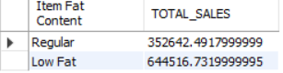

**Low Fat Content has more sales**

**Now analysing total sales by Item type:**

* **SELECT `Item Type`, SUM(`Total Sales`) AS TOTAL_SALES**

**FROM blinkgroc**

**GROUP BY `Item Type`;**

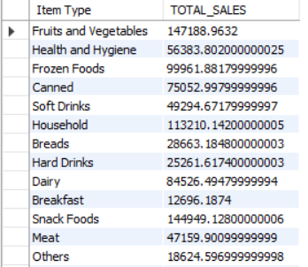

**Fruits and vegetables give more sales as compared to other Item types.**

**This can be attributed to the fact that these are low fat content items.**

**Now analysing Fat Content by Outlet for Total Sales:**

* **SELECT**

**`Outlet Location Type`,**

**COALESCE(SUM(CASE WHEN `Item Fat Content` = 'Low Fat' THEN `Total Sales` ELSE 0 END), 0) AS Low_Fat,**

**COALESCE(SUM(CASE WHEN `Item Fat Content` = 'Regular' THEN `Total Sales` ELSE 0 END), 0) AS Regular**

**FROM (**

**SELECT**

**`Outlet Location Type`,**

**`Item Fat Content`,**

**CAST(SUM(`Total Sales`) AS DECIMAL(10,2)) AS `Total Sales`**

**FROM blinkgroc**

**GROUP BY `Outlet Location Type`, `Item Fat Content`**

**) AS SourceTable**

**GROUP BY `Outlet Location Type`**

**ORDER BY `Outlet Location Type`;**

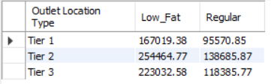

**Total sales by outlet Establishement:**

* **SELECT `Outlet Establishment Year`, CAST(SUM(`Total Sales`) AS DECIMAL(10,2)) AS Total_Sales**

**FROM blinkgroc**

**GROUP BY `Outlet Establishment Year`**

**ORDER BY `Outlet Establishment Year`;**

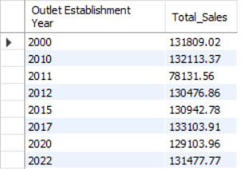

**Sales by outlet location:**

* **SELECT `Outlet Location Type`, CAST(SUM(`Total Sales`) AS DECIMAL(10,2)) AS Total_Sales**

**FROM blinkgroc**

**GROUP BY `Outlet Location Type`**

**ORDER BY Total_Sales DESC;**

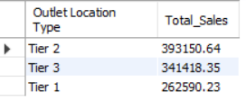

**Tier 2 Outlet gives Maximum sales so the company must focus to expand their operations for Tier 2 Locations.**

**All metrics by outlet type:**

* **SELECT `Outlet Type`,**

**CAST(SUM(`Total Sales`) AS DECIMAL(10,2)) AS Total_Sales,**

**CAST(AVG(`Total Sales`) AS DECIMAL(10,0)) as Avg_Sales,**

**COUNT(*) AS No_Of_Items,**

**CAST(AVG(`Rating`) AS DECIMAL(10,2)) AS Avg_Rating,**

**CAST(AVG(`Item Visibility`) AS DECIMAL(10,2)) AS Item_Visibility**

**FROM blinkgroc**

**GROUP BY `Outlet Type`**

**ORDER BY Total_Sales DESC;**

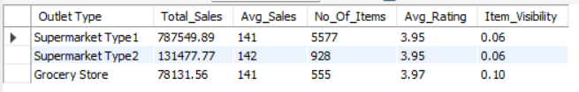

**Supermarket type 1 has higher sales so company should focus more here.**

**Percentage of Sales by outlet size:**

* **SELECT `Outlet Size`,**

**CAST(SUM(`Total Sales`) AS DECIMAL(10,2)) AS Total_Sales,**

**CAST((SUM(`Total Sales`) * 100.0 / SUM(SUM(`Total Sales`)) OVER()) DECIMAL(10,2)) AS Sales_Percentage**

**FROM blinkgroc**

**GROUP BY `Outlet Size`**

**ORDER BY Total_Sales DESC;**

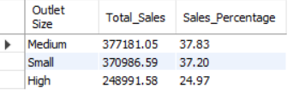

**Conclusion:**

* **The company should focus on opening more supermarket type 1 store of medium sizes in tier 2 cities to increase their sales.**
* **The comapny should also focus on selling Low Fat Content items like Fruits and Vegetables as this gave them more sales.**
* **The average rating is nearly 4 and it can be increased above 4.5 by training delivery partners and maintaining quality of products.**